Veganism

We at Peedus People value Veganism as a way of life. We have created a group of Vegans in our area under the group ‘ Vegans In Chandigarh’. We promote Veganism as a means to be kind to animals, humans and the environment. While we do not force it on anyone of our volunteers or employees but we run the NGO on the principles of Veganism and Kindness



1. How we define Veganism

Veganism is a way of living that attempts to exclude all forms of animal exploitation and cruelty, be it from food, clothing, or any other purpose.

1. Why do people turn Vegan

Vegans avoid animal products for one or more of the following reasons.

### *Ethics

Ethical vegans strongly believe that all creatures have the right to life and freedom.

Therefore, they oppose ending a conscious being's life simply to consume its flesh, drink its milk, or wear its skin — especially because [alternatives](https://www.healthline.com/nutrition/best-milk-substitutes) are available.

Ethical vegans are also opposed to the psychological and physical stress that animals may endure as a result of modern farming practices.

Vegans speak out against the farming industry’s practices, such as the grinding of live male chicks by the egg industry or the force-feeding of ducks and geese for the foie gras market.

Ethical vegans demonstrate their opposition by protesting, raising awareness, and choosing products that don’t involve animal agriculture.

### *Health

Some people choose veganism for its [potential health effects](https://www.healthline.com/nutrition/vegan-diet-benefits).

For example, plant-based diets may reduce your risk of heart disease, type 2 diabetes, cancer, and premature death.

Lowering your intake of animal products may likewise reduce your risk of Alzheimer’s disease or dying from cancer or heart disease

Some also choose veganism to avoid the side effects linked to the [antibiotics](https://www.healthline.com/nutrition/antibiotics-in-your-food) and hormones used in modern animal agriculture

Finally, studies consistently link vegan diets to a lower body weight and body mass index (BMI). Some people may choose these diets to lose weight

### *Environment

People may also choose to avoid animal products because of the environmental impact of animal agriculture.

A 2010 United Nations (UN) report argued that these products generally require more resources and cause higher greenhouse gas emissions than plant-based options.

For instance, animal agriculture contributes to 65% of global nitrous oxide emissions, 35–40% of methane emissions, and 9% of carbon dioxide emissions.

These chemicals are considered the three principal greenhouse gasses involved in climate change.

Furthermore, animal agriculture tends to be a water-intensive process. For example, 550–5,200 gallons (1,700–19,550 liters) of [water](https://www.healthline.com/nutrition/7-health-benefits-of-water) are needed to produce 1 pound (0.5 kg) of beef.

That’s up to 43 times more water than is needed to produce the same amount of [cereal grains](https://www.healthline.com/nutrition/9-benefits-of-whole-grains).

Animal agriculture can also lead to deforestation when forested areas are burned for cropland or pasture. This habitat destruction is thought to contribute to the extinction of various animal species

In todays world Veganism is the only sustainable solution for-

-Our health and nutrition.

-The environment

-For equality and tolerance.

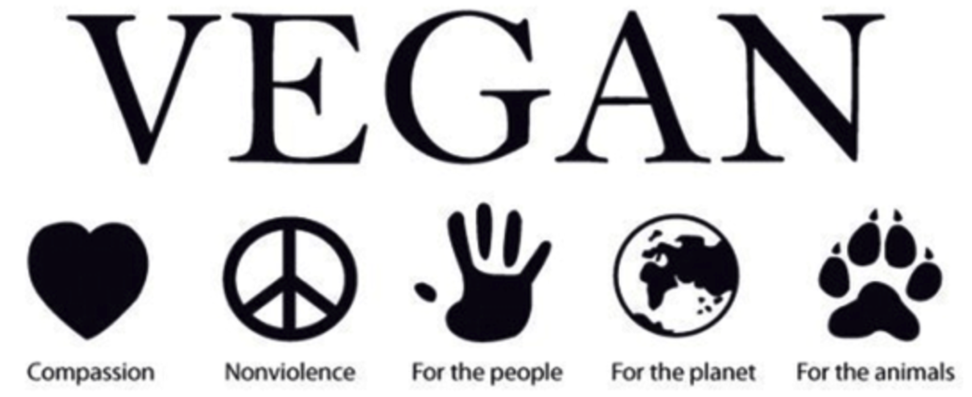

Subpages-

1. BELIEFS

*Anti-Speciesism

*Using cruelty-free products for make-up.

*

1. OUTREACH

We conduct regular outreach programs to promote Veganism in innovative ways.

*Restaurant Outreach

*Documentary Screenings

*Direct action and outreach.

*Monthly Potlucks

*Awareness in Schools and Colleges

*Sports programs (Cricket matches/ Bicycling events/ Running events)

*Protests against animals used in laboratories.

*Vegan fairs and conferences.



